Portfolio Project Tableau

Jon Brookins

ACT 425 Information Systems for Accounting

Colorado State University – Global Campus

Dr. Jennifer Bolden

October 5, 2019

Portfolio Project Tableau

Tableau was created by students at Stanford University. The data visualization program was developed as a tool to analyze data from many different sources. The Tableau program has a simple and user-friendly drop and drag menu. The Tableau interface allows users develop maps, graphs, and charts. Using Tableau visualization tools to analyze complex data, users can create easy to understand data analysis maps, graphs, and charts for end-users. Advanced concepts included in Tableau include predictive and prescriptive data analysis. Tableau users are able to incorporate data analysis to help businesses in the decision-making process. A large selection of training courses and how-to videos are offered to help users learn to effectively harness data using Tableau.

**Overview**

**Costs**

Tableau is offered at several price points to accommodate large and small business needs.

Tableau can be hosted on a cloud server or Tableau can accommodate server needs. Tableau’s monthly subscriptions range from $12 - $70 per month. Tableau offers students a free one-year subscription.

**System Requirements**

Tableau requires users to have Windows 7 or newer, an Intel Pentium 4 or AMD Opteron processors or newer, greater than 2 GB of memory and a minimum of free 1.5 GB disk space. Mac requires Mac OS 10.11 or newer and a minimum of free 1.5 GB disk space. Most newer model computers are capable of running Tableau software.

**Data Connections**

Tableau is able to connect to numerous data sources. Excel is the principal and most convenient connection for accounting professionals. Tableau data connect sources include JavaScript Object Notation (JSON) files, Portable Document Format (PDF) files, Spatial files, text files and statistical files. Google sheets was added in version 10 of Tableau. The connect pane is the primary way to connect to data sources.

**Functionality**

Tableau is one of the leading business intelligence systems that assists organizations to visualize and comprehend data. The system provides exceptional benefits to clients and have reported that the data helps in decision making and setting and a company towards profitability and competitiveness (Baldwin, 2016). Tableau features allows users to connect information from different sources. Tableau assists with quick and easy summary and analysis of complex datasets. The system allows collaboration by employees working on the same or different projects. This ensures project awareness by all employees in a business, encourages cooperation and productivity.

**Data Management**

**Data Connections**

Data can be accessed in numerous forms with Tableau. Tableau can connect to a file in countless formats: Microsoft Excel, Text file, JSON file, PDF file or Spatial File Statistical File. Tableau has built-in servers that can be accessed: Tableau Server, Microsoft SQL Server, MYSQL, Oracle and Amazon Redshift. A data source may be saved in Tableau for future access.

Tableau uses an easy format to import or connect to datasets.

When Tableau is launched, the data connection option is presented in a list format in the Connect pane. The connect pane is located on the left side of the start page. The Connection pane contains the options: connect to a file, a server or more. File types include Microsoft Excel, Text file, JSON file, PDF file or Spatial File Statistical File. Popular servers offered include Tableau Server, Microsoft SQL Server, MySQL, Oracle, and Amazon Redshift. The more options tab offers many server options. Tableau 10 added Google sheets to the connect pane.

**Data cleanup**

Sometimes the data format is not perfect or machine-readable for Tableau use. It is important to first connect to a dataset and explore the data. Tableau automatically categorizes data into dimensions and measures. Each dimension or measure contains data pills. Data pills comprise the data related to the labeled measure or dimension. Dimension data is placed into the row’s columns for Tableau worksheets. A measures pill may be placed in the columns or marks box. Placing a measures pill in the columns box will create a bar chart. Placing a measures pill in the marks box allows the data to be aggregated as text in the dimensions screen to the level of the rows data.

Columns and Rows:

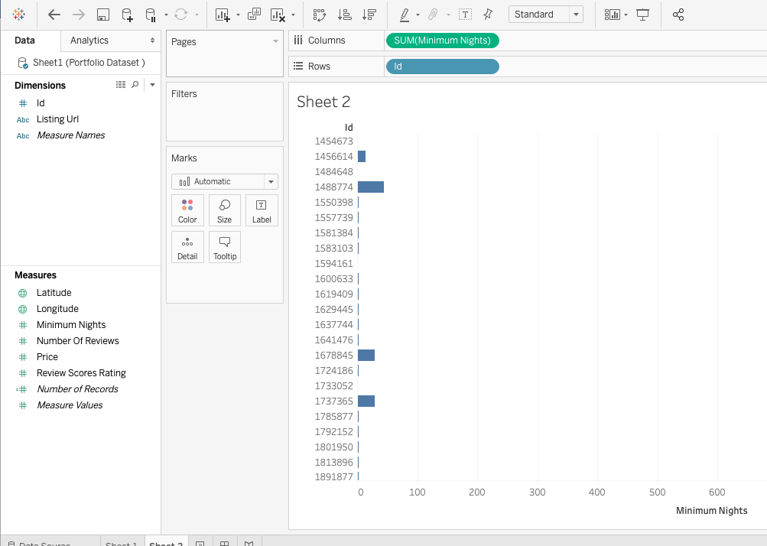

Rows and Marks:

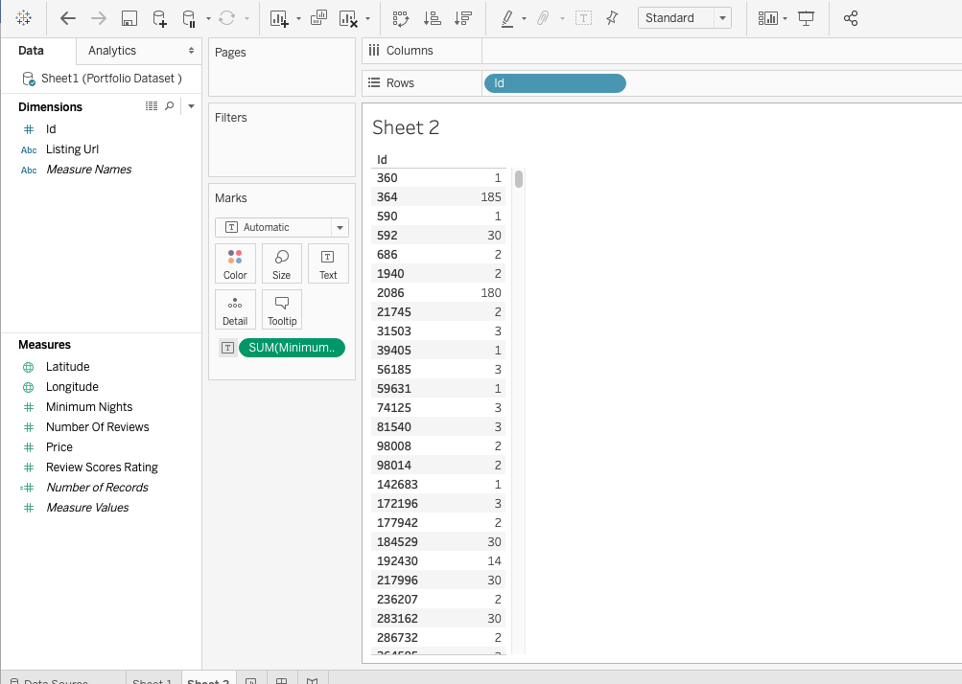

The dataset may require formatting. An example of simple formatting is converting dates from string data into discrete date format. This will improve the ability of Tableau to read and apply the data. Another type of formatting is performing a data split. An example would be city and state data formatted as string data. By performing a data split, city and state data can be moved into separate columns. This action splits the data into two columns – city and state. Measures can be integer numbers that need to be used as dimensions. A common integer measure that can be used as a dimension is year. The simple task of dragging the year pill from the measure box to the dimensions box allows data to be classified by year. An example would be sales by year.

**Field Joins**

Datasets may contain a collection of tables. Tableau is able to join a collection of tables that share a column with same data type. The result of joining tables is an extension of the dataset by adding additional columns of data. It is common for multiple tables for customers to contain the customer identification number. By joining tables based on the customer identification number, the dataset for analysis expands significantly. There are four types of joins: inner join, left join, right join, full outer join and a union. An inner join has values that match from each table. A left join has data from the left table and matching data from the right table. A right join has data from the right table and matching data from the left table. A full outer join combines data from both tables.

**Visualizations**

Visualizations are created in Tableau using the “Show Me” icon in the upper right-hand corner of the data tab. The different types of visualizations include text tables, symbol maps, horizontal bars, treemaps, continuous line charts, continuous area charts, scatter plots and Gantt view charts. Hovering over each chart type gives the required data to form each chart. The data requirements include measures, dimensions, date, longitude and latitude.

**Worksheets and Workbooks**

**Story line**

Tableau conveys a story data with visualization. The visual aids use data to create a narrative, give data context, aid in business decision, and to make a captivating business story.

Tableau can be used to measure outcomes related to previous decisions and to project into the future possible outcomes for current business options. A story line should with a wide lens on the available data. Each successive data visualization should drill down on the data to convey a comprehensive story.

Story Line

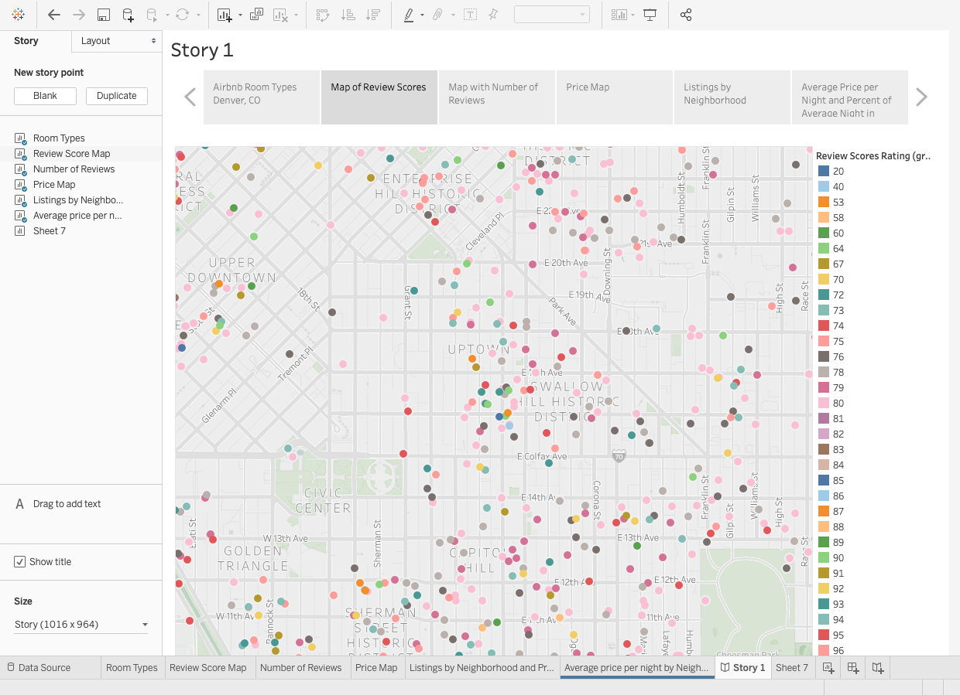

**Custom Calculation**

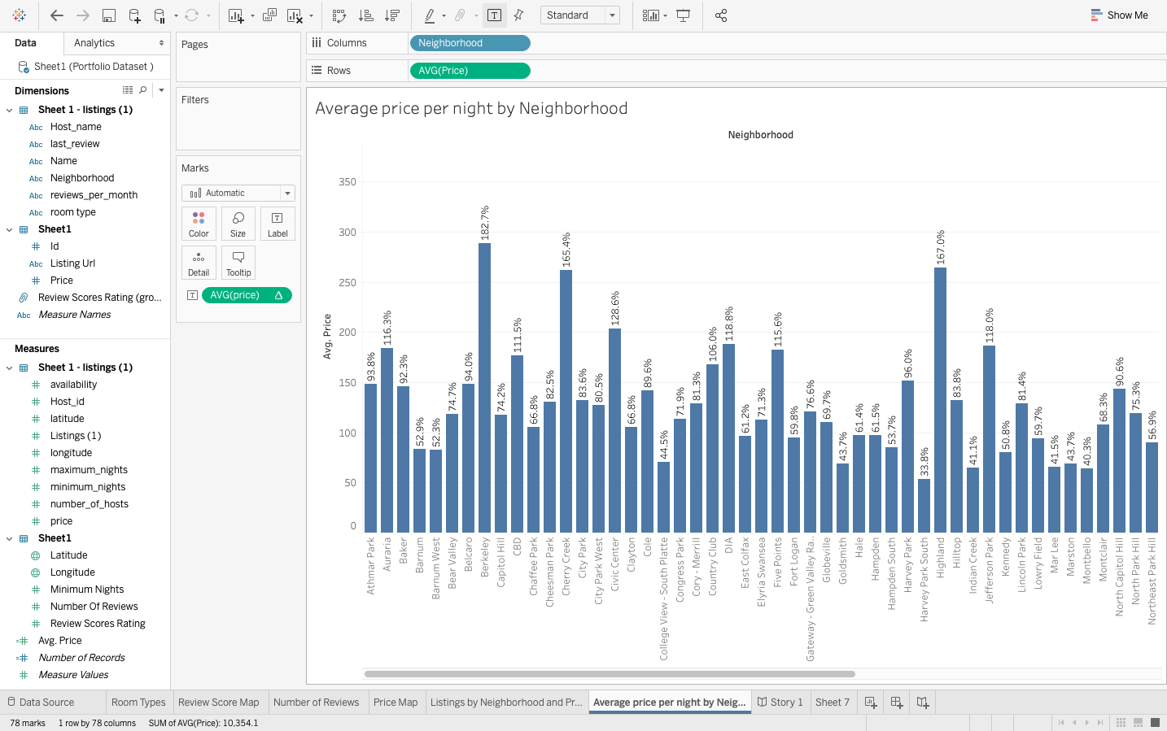

**Data and Statistical Analysis Tools**

Statistical analysis tools use data to describe, summarize and compare data. Statistical analysis can range from basic, simple computations to advanced, complex analysis.

Descriptive analysis uses simple calculations that gives a picture of what the data looks like overall. Descriptive analysis tools include: frequency, percentages and measures of central tendency. Moderate statistical analysis looks at the relationships between variables in data. These include correlation and regression. Advanced analysis uses calculations of variance in data. Advanced analysis shows the diversity that exists in the data and positive outcomes.

**Filtered and Sorted Data**

Data in Tableau can be filtered on the filter shelf, with an interactive filter or in the view. Using the filter shelf, a data pill is dragged directly to the filter shelf pane above marks. An interactive filter can be provided for the user analysis and manipulate data in the view pane. The interactive filter is applied by right clicking on the data pane. In the visualization pane right-clicking on any column or category will access a menu to exclude or include data. There are several ways to sort data in Tableau. By right clicking on data, columns can be sorted in ascending and descending order. Right-clicking on an axis, header, or field label accesses the menu for sorting data. Other available sorting options include sorting manually in headers and legends, using the toolbar sort icons, or sorting from the sort menu.

Filtered by Room Type – Private Room.

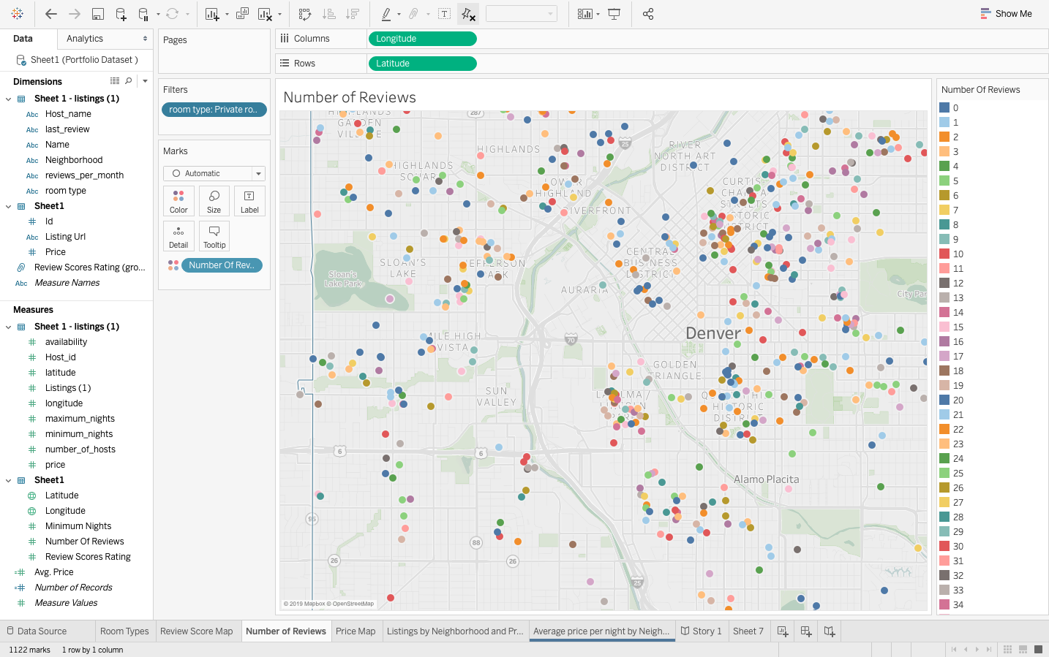

Filtered by Neighborhood – Athmar Park

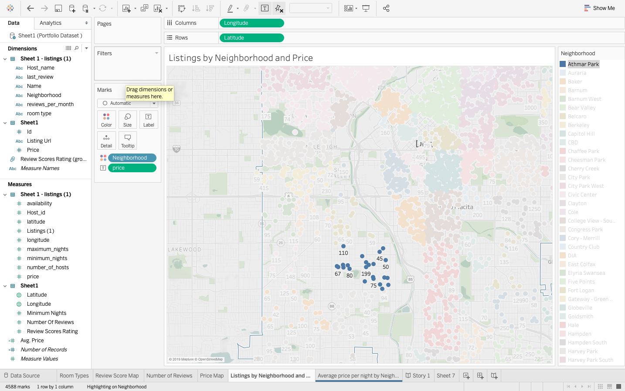

Sorted by Highest Percentage of Average Price – Denver

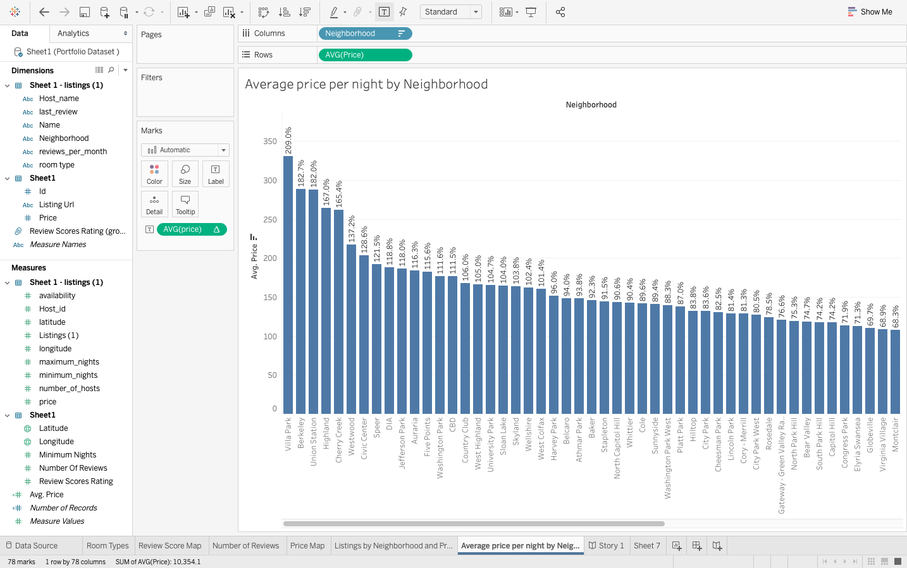

Sorted by Neighborhood Alphabetical – Denver

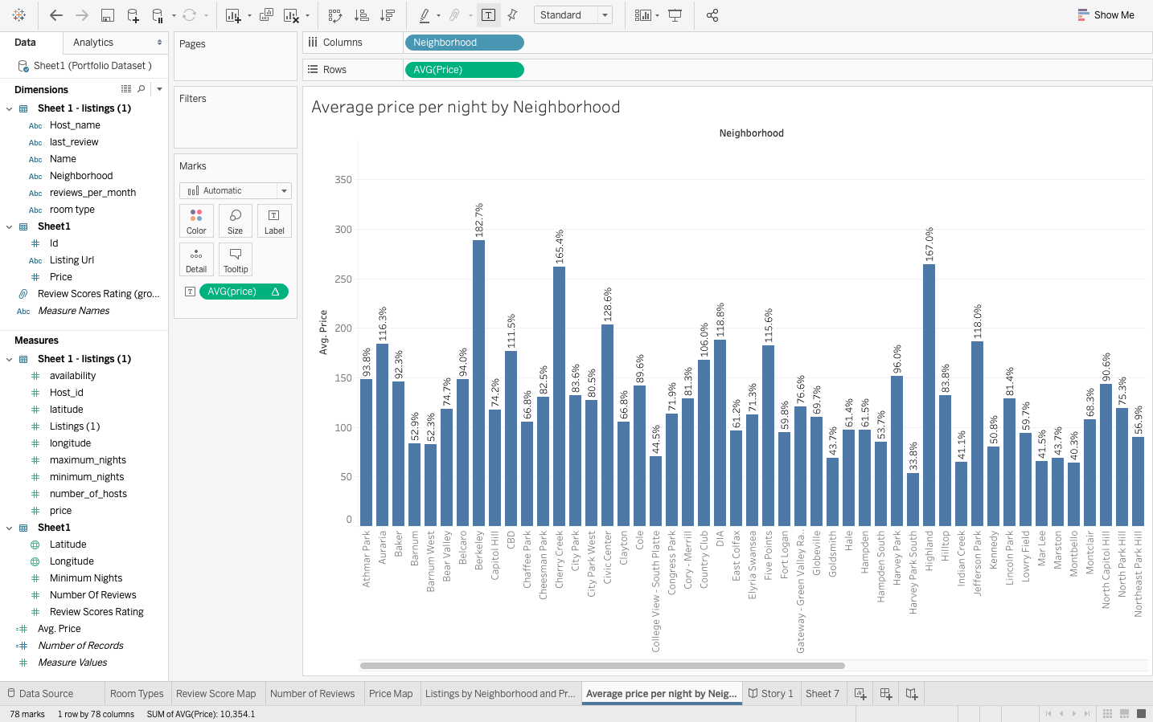

Group by Neighborhood Alphabetically

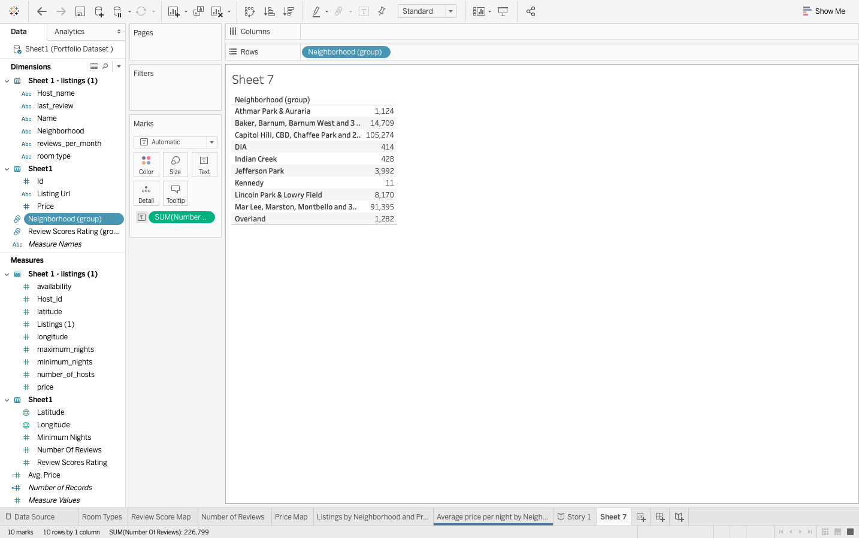

**Sets**

Neighborhoods with <5 rentals

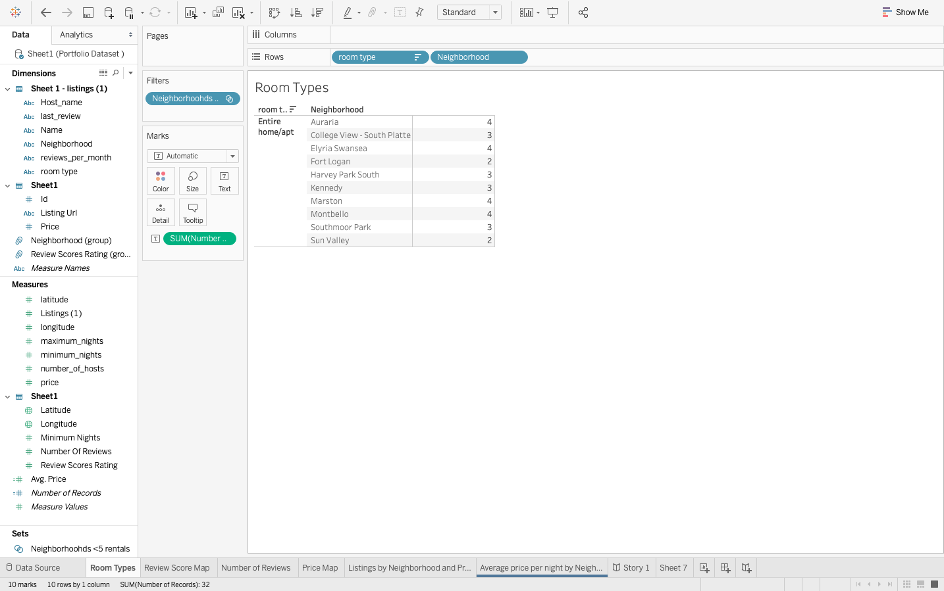

Neighborhoods with >100 rentals

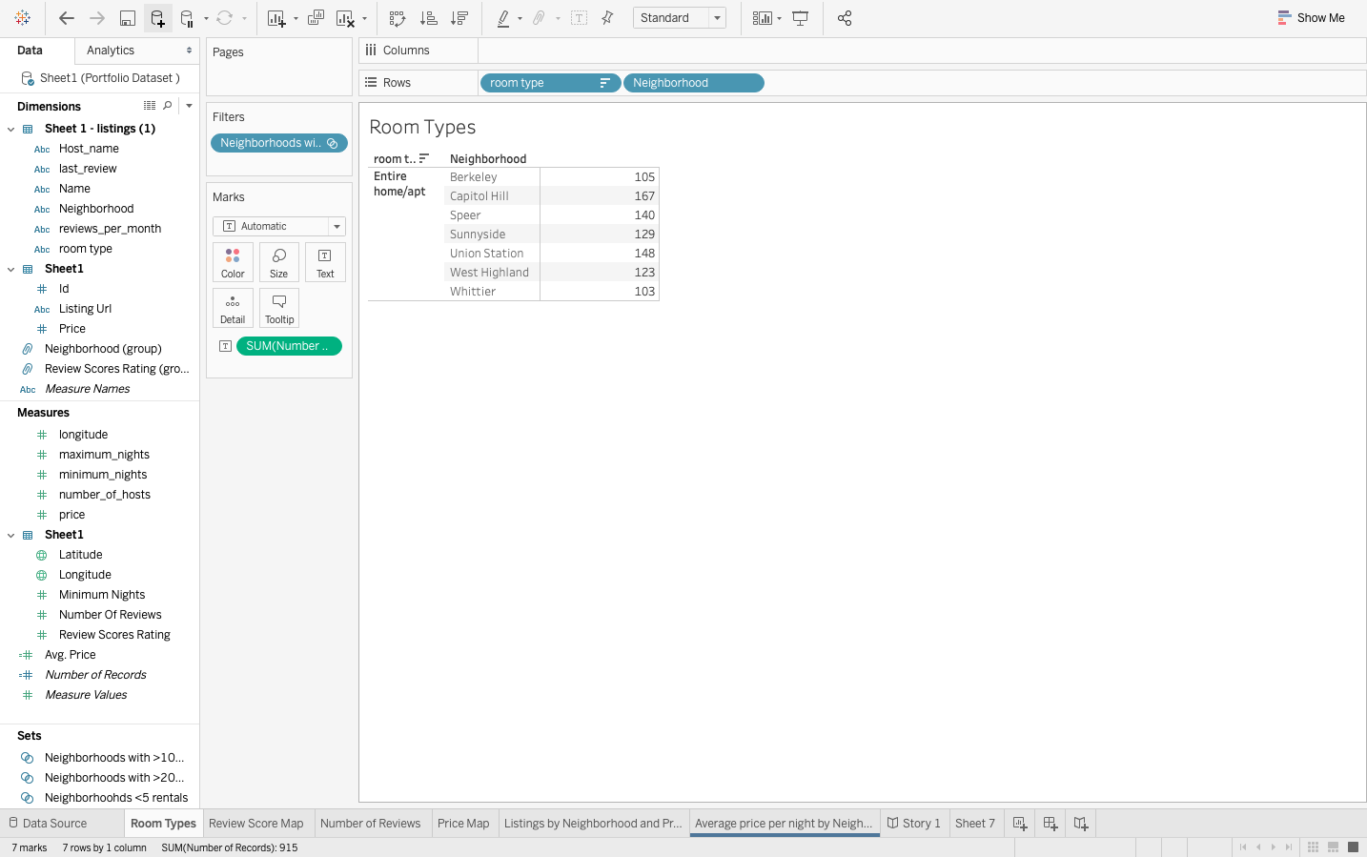

**Neighborhoods with >200 rentals**

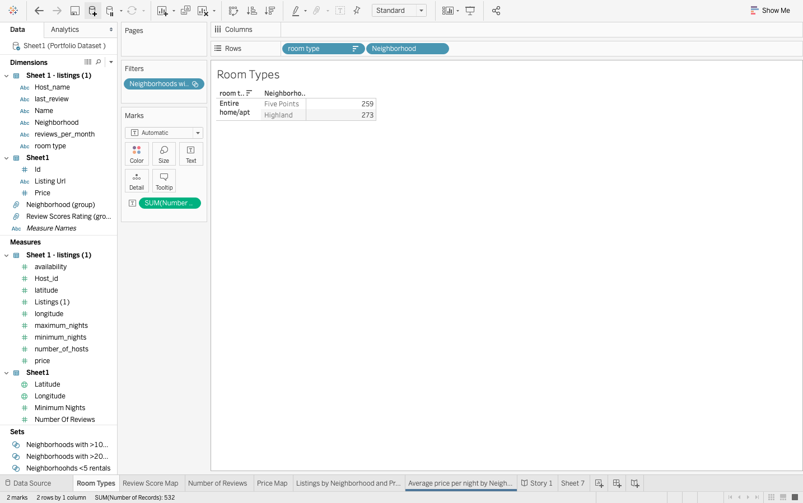

**Internal Controls**

**Data Analysis – Airbnb Data**

The first step in internal controls is risk assessment. Accountants can collate and blend the data to identify trends or patterns in the data. The next step is planning and testing. With the Airbnb data, accountants can perform complex analytical reviews to identify anomalies that require further inquiry. These anomalies can be compared to wider time series to identify useful patterns of inquiry. The accountant is able to drill down transaction related data to identify high risk versus low risk transaction. The final phase is reporting. By combining the dataset combined with high sampling, the accountant is able to identify anomalies quicker and with more accuracy. Using Tableau provides the accountant the ability to represent the information visually. By visualizing the information, the end-user can gain more insightful information. The information becomes actionable in the business decision making process.

**Security Issues and Internal Misuse**

Hacking and spoofing are the primary security flaws in Tableau. It is important ot maintain servers within a company’s firewall. Access to projects can be manages by groups or by granting individual access. Information is considered controlled access or open-access. Human resources data would have controlled access. Project workbooks are managed at the project level. One person should be designated to manage permissions to controlled access worksheets. An underestimated issue with Tableau is internal misuse. Input and output misuse are the primary issues. An important audit point is tracking changes to access for controlled accesss workbooks and worksheets.

**Charts and Graphs**

**Aggregate Function**

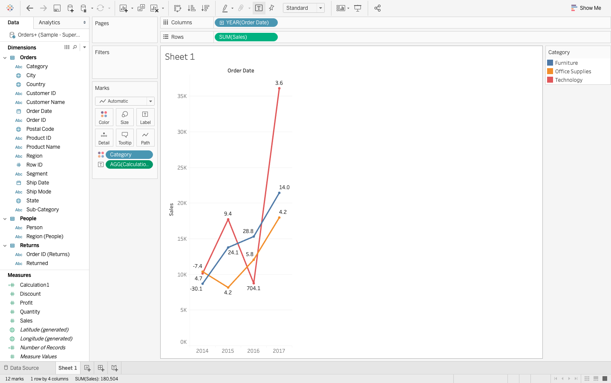

**Number Function**

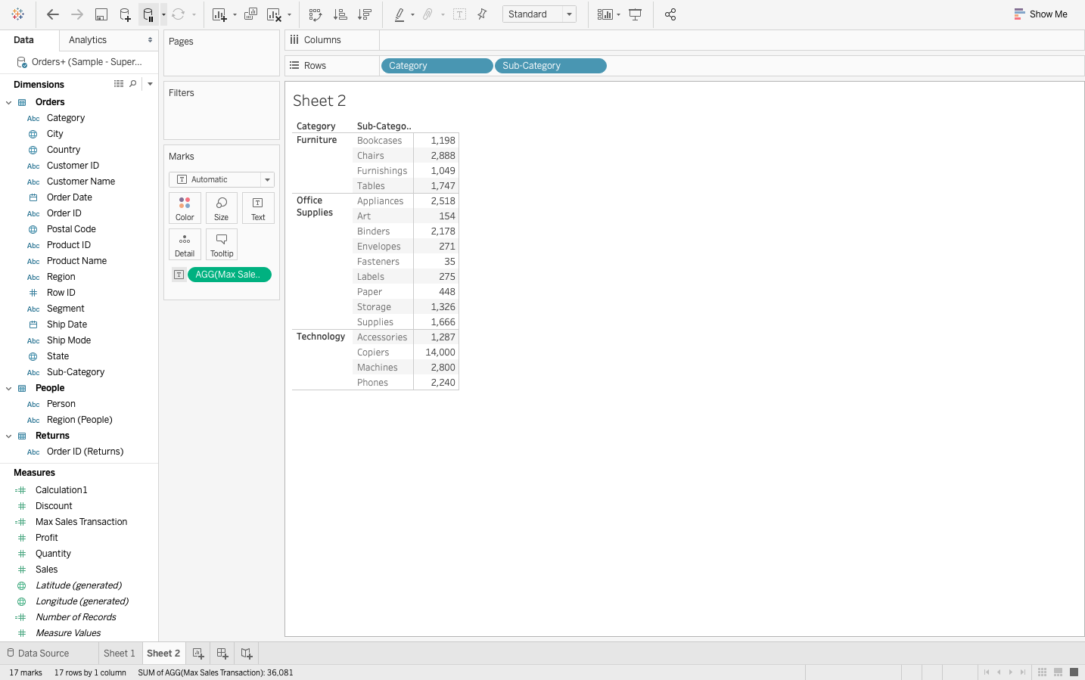

**Logical Functions**

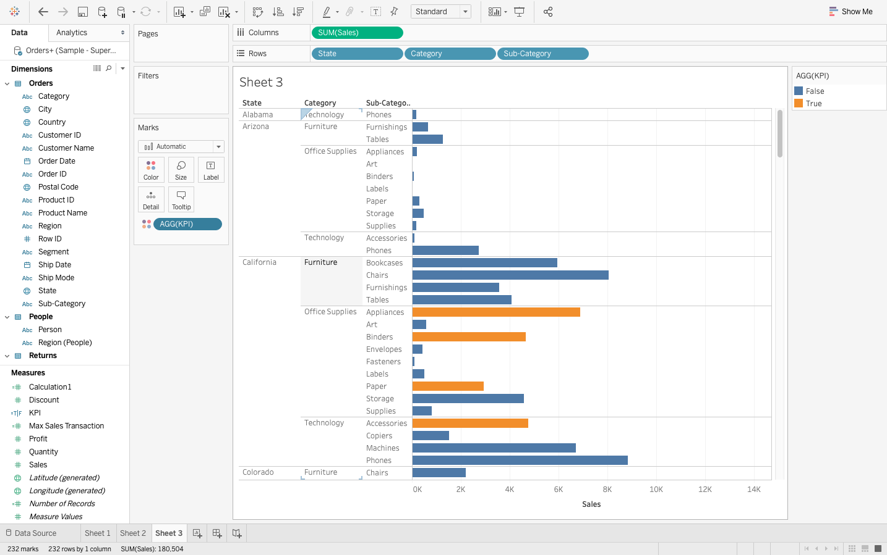

**Pie Chart**

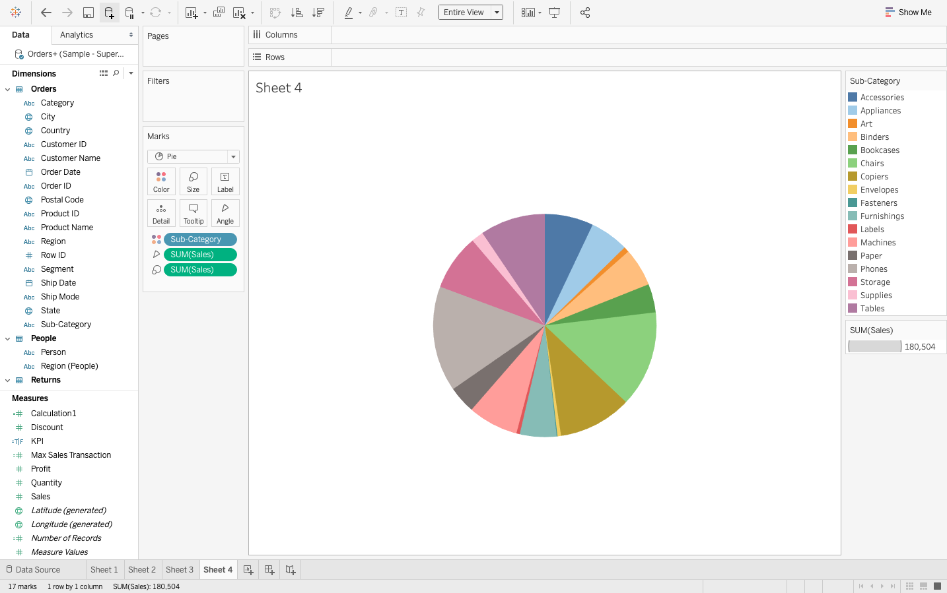

**Area Chart**

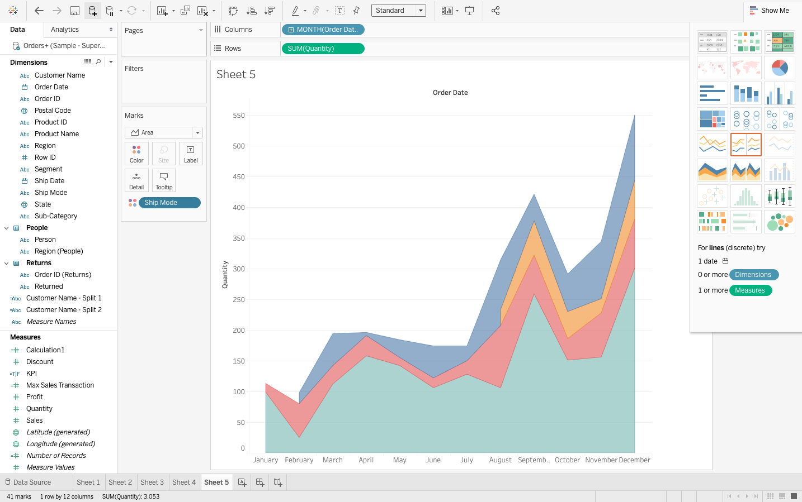

**Data Diagram**

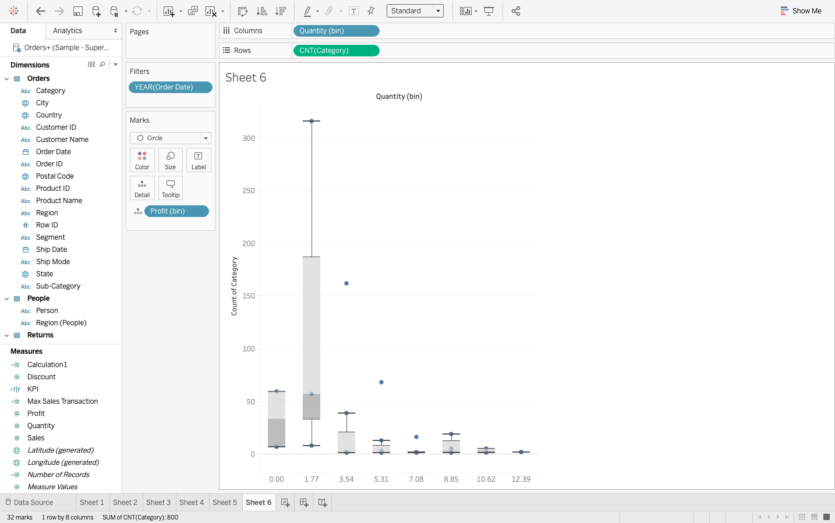

**Conclusion**

Tableau is powerful data analysis tool. Using big data to create a story through the visualization of data improves the business decision making process for small and large businesses. In accounting, the applications are endless with improved auditing and internal control applications. Trends and anomalies can be detected and investigated earlier. The opportunity to intervene earlier can decrease fraud and losses for businesses. Combining Tableau with accounting skills will increase marketability for any accounting graduate.

References

Baldwin, D. (2016). *Mastering Tableau*. Birmingham Packt Publishing 2016.

Build a Pie Chart Version: 2019.3 Applies to Tableau Desktop, Tableau Online, Tableau Public, Tableau Server. (n.d.).

Create an Area Chart Version: 2019.3 Applies to Tableau Desktop, Tableau Online, Tableau Public, Tableau Server. (n.d.).

Frandsen, A., Walrath, R. (2017). How to: Create a Tableau Map Using Airbnb Ratings Data.

Ruggles Media. Retrieved from https://camd.northeastern.edu/rugglesmedia/2017/11/02/how-to-create-a-data-map/

Khan, A. (2016). Jumpstart Tableau: A step-by-step guide to better data visualization. Top of Form

Apress, New York, NY: Distributed to the Book trade worldwide by Springer 2016.

Logical Functions Version: 2019.3 Applies to Tableau Desktop, Tableau Online, Tableau Public, Tableau Server. (n.d.).

Number Functions Version: 2019.3 Applies to Tableau Desktop, Tableau Online, Tableau Public, Tableau Server. (n.d.).

Simkin, M. G., Worrell, J.L., Savage, A. A. (2018). Core Concepts of Accounting Information Systems, 14th Edition [VitalSource Bookshelf version]. Retrieved from vbk://978111373544.

Strings Functions Version: 2019.3 Applies to Tableau Desktop, Tableau Online, Tableau Public, Tableau Server. (n.d.).